Governance & BCP/DR

Thursday, June 24, 2021

**Attendees**: Seun Mafi, Daniel Benner, Biven Patel, Daniel Rodrigues, Konrad Wisniewski, Mark Lojo, Michael O'Neill, Sol Vazquez, Nicholas Lombardo, Aizaz Ahmad, Srinivas Bandapalli, Eric Mata.

**Location:** WebEx

**AGENDA**

**Sri**: As an enterprise, we create a business continuity plan for IT, and there are section within that cognizant follows. They do not have a specific plan for Prod support, they follow the business continuity plan for the engagement. No specific outlined plan.

The way the contract goes, is they follow BCP within CVS. Whether prod support or other areas. They follow through.

The BCP is not application specific. It is data engagement.

**Dan: Disaster recovery plan?**

**Sri:** They follow the standard user category and plan. They follow the enterprise standard. There is nothing specific for cognizant.

**Dan: Are the roles and responsibility specified somewhere?**

**Sri:** You can find in the SLA. It contains the SLA for each. The principle around these processes is that they have to follow the enterprise standard. (Say tomorrow , they come up with a new process, As they make changes, Cognizant is contracted to follow Enterprise standard.)

**Dan: Testing Schedule, Are they different?**

**Sri:** Enterprise standard. If application is to be tested once a year, they follow through. If its July, they have to follow the timeline. All the guidance comes from the disaster recovery team. We make sure they are following the enterprise standards.

We do monthly review. They will show how they did against the DR plan.

**Mike:** The application owner needs to approve the DR plan.

**Dan: Change to DR plan, how is it updated?**

**Sri**: Changes are done based on upgrades done to application. Every time we go through the planning before we execute. They review all the architecture changes and based on that they will adjust the plan and get it approved. There is a schedule published by DR team. They review any changes, and based on that, new infrastructure gets added accordingly before the testing happens.

**Mike:** On my application, the plan needs to be reviewed before being signed off.

**Eric: You mentioned a weekly and monthly process for review?**

**Sri:** We schedule tower level review that occurs weekly and monthly. Part of governance meeting. They review all aspects of Prod support. Alerts, etc and then they will review with my directors. That's the process. If there is something related to disaster recovery, they will give us a notice and say this is coming up. Planning starts then, executing starts then and ends then. They will highlight to us. Part of the Governance model we created.

**Dan: Process of backing up data?**

**Sri:** They all follow the DR tier model. In other to be at a particular Tier level, the infrastructure is created that way. Say the RPO is within 4 hours. There should be a data saying in 4 hours. They are done with the infrastructure build. Adjusted accordingly. We evaluate what infrastructure change behind the scene. Prod Support will maintain as though it was given to us.

**Dan: Bringing up the agreement. Mention RTO is 72 hours, and 24 hours. (RTO - Recovery Time objective) Please explain further**

Machine generated alternative text:
34.0 Pisaster Recoverv 
The Vendor shall create, implement and maintaln a no less than industry standard disaster recovery 
program for their Product or Service that provides a formal framework and methodology to Identlfy and 
prioritize cntlGaI business functlons, The Vendor must supply that plan to CVS annually during a review 
meeting with the CVS EDR Team. The Vendor must execute and complete a successful DR test every 
12 months, allow tor CVS participation in the test (it CVS Health requests) and provide CVS Health with a 
complete test report. including a remediation plan tor any areas that do not meet the 
established by the dlA. 
The CVS EDR Team will review any SOWS established by the Vendor or CVS that pertain to any disaster 
recovery times or objectives. 
Page 22 ot 53 
Services Agreement 
Confidential 
DO or distribute without prim written consent by CVS 
2.15 

**Sri:** The recovery objective is determined by the organization The RTO guideline for Tier 1 is 4 hours. No data loss beyond 4 hours. In automation center, it is different. RTO means data recovery.

Machine generated alternative text:
Unified Enterprise BC/DR Tier Structure 
Business 
Tier 2 
CritO to 
regulatory 
ication Service 
Criticality 
Financial Impact 
< 4 H4Jrs 
Th reatens 
corgxrate surviO 
witu:nn 
rekxatim and/or 
restuation IT 
infrastructure and 
Material dollar bss 
tied to CINItiru_Ed 
åsruptm 
c«atim 
of the business 
fmcbons car"Üt 
pedormed 
nun uany for rnore 
than 2-3 days 
wtttout 
th•eamng 
survival 
Material dollar 
loss tied to 
continued 
Hours 
Critical to the 
weration 
ot busirkss 
manuany a 
shut penod (I 
week) vathout 
threataung 
surviva 
Dollar loss high, 
but controllabe 
the shut term 
Days 
DisnQtion can 
Funct•cms can 
J*rfornted via 
of 
to urut(s) 
Ddlar loss is 
»7Davs 
Best Effort 
Days 
Disruptm cm 
Funcbons CM 
via 
wukuound or 
albcation of wcn 
unit(s) 
loss 
•CVSHealth 

**Sol: Have we ever experience when our application was down and we had to recover?**

**Sri:** I don't believe we have. This application has not been down.

**Sol: What is Cognizant involvement? I understand there is some info in the contract. If we make changes on our end, how are they aware of our BCP/DR plan? We are specifically asking about DR plan.**

**Sri:** The enterprise disaster recovery team schedule and their responsibility is to manage the plan and executive the disaster recovery testing. They are communicated directly. They pick up from there and run with it. They work directly with the disaster recovery team.

**Dan: Can you explain where you find these disaster recovery time?**

**Sri:** Disaster recovery will follow enterprise standard and the application Tiering changes. We execute change order twice a year.

**Sol: Do we have a clause statement?**

**Sri:** Do a quick search on change control. We have a weekly call that we go through and its part of this

**Dan: Contingencies if cognizant is not able to provide Production support?**

**Sri:** There is a waiting period defined in the document. Stats how long they need to provide. There are clauses defined in the document. Also defined a number of days they will provide assistance to the new team coming on board. We have an option to negotiate the licensing on those items. I think its about 90 days transition to provide support to a new team etc.

**GOVERNANCE:**

**Dan: Framework for the governance process?**

**Sri:** Withing the doc, you will find the engagement level, status meeting, monthly level meeting, quarterly meeting with Ajoy. We go through these items. And they can clearly defined on the accountability. You will also see an operating module.

**Dan: How are we ensuring the KPI's are being met?**

**Sri:** There are weekly and monthly calls. Basically, every month, we review the data for accuracy and review number to make sure they are in line. We have an approval process. We sign off on the numbers, we evaluate the data, and based on that, they get paid.

**Dan: What are discussed during the weekly meetings?**

**Sri:** See how the engagement is going. How they are doing in general. Slowly builds up to a monthly deck then we sign off on it. There is a dashboard we can verify. There is data that goes behind the metrics.

Expected performance means it has to be done.

Machine generated alternative text:
Attachment C — Service Level Methodology, Exhibit C-1 Service Level Matrix, Section '2. Key 
Performance Indicators' is amended to change the below KPls 
2.13 
2.14 
2.15 
2.16 
2.19 
227 
228 
CSL Name 
Draft RCX)t Cause Analysis (RCA) Completed (PI) 
Draft Root Cause Analysis (RCA) Cornpleted 
(P2/P3 - Escalated) 
Service Request Response Time Priority Level 3 
Service Request Response Time Priority Level 4 
Data Fixes prbrity Level 3 Respmse 
Data Fixes Prbrity Level 4 Respmse 
Data Fixes Priority Level 3 Resolution within 24 
Hours 
Data Fixes Priority Level 4 Resdution wittin 24 
Hours 
Service Request Resolution Tune Priority Level 3 
within 24 hcn•rs 
Service Request Resolution Tine Priority Level 4 
within 24 
Expected 
performance 
24 Hours 
1 Business day 
1 Business day 
1 Business day 
1 Business day 
I Business day 
1 Business day 
I Business day 
I Business day 
Expected 
100% 
100% 
95% 
95% 
95% 
95% 
50% 
50% 
Measurement 
Period 
Monthly 
Monthly 
'&thly 
Business 
Hours 24•7 
24•7 
24•7 
Business Hours 
Business Hours 
Business Hours 
Business Hours 
Business Hours 

**Dan: On the topic of KPI, If its in a negative trend? What do you do?**

Sri: They are supposed to provide a root cause analysis. We should take a KPI and assigned to a CSL. So we can shift the Kpi and reporting metric to a CSL. If we fill the people are not doing well in one area.

**Dan: How often?**

**Sri:** We still building and trying to measure. It occurs once in 6 months. We do changes to the contract once in 6 months. A lot of factor goes into the change order.

**Eric: Do we create any reporting in house?**

**Sri:** there is an enterprise resource team. We leverage the data to challenge some of these items. We have a team that takes the ticket data. Comes from our enterprise team. A process to check all that they are reporting. Ticket data is coming from snow.

**Eric: Do you create any reporting that shows these KPI, they arent trending in the fashion that it should. Need to move from KPI to CSL?**

**Sri**: It will be discussed as part of the change council meeting. We bring any item of concern to the internal meeting. If we decide to change a KPI to a CSL, we decide on that during the meeting. We have governance meetings every week.

**Dan: Under the reporting section. You have 5 different report under different frequencies**.

Machine generated alternative text:
Mechanism 
W eekly 
Performance 
Reports 
Monthly 
Performance 
Reports 
Quarterly 
Business Review 
Satisfaction 
Survey 
Service Level 
Default Root 
Cause Analysis 
Governance Communications 
Description 
Repon detailing the performance results achieved for the Service 
Levels (CSI_s, KPls and RMS), performance trend observations 
(as applicable). 
Report detailing the performance results achieved for the Service 
Levels, high-level summary of failure trends and critical action 
plans for Service Level Defaults. Continuous trend analysis and 
action plans. Improvement opportunities. 
Quarterly summary of tactical SOW Services performance, 
including performance against Service Levels; highlights of SOW 
Services delivery; status of major SOW Services issues; and 
major Project implementation impacts. 
Quarterly summary of strategic relationship performance, 
including CVS business updates; relevant Cognizant business 
updates; industry trends; new initiatives; and challenges I 
obstacles / opportunities. 
Output summary report regarding results of the Satisfaction 
Survey. The survey content, recipients, scoring method and other 
details will be mutually agreed upon prior to the start of the 
Steady State phase. 
Report detailing the root cause for any Service Level Defaults as 
detailed in Attachment C, Service Level Methodology. This 
report will also give details of all steps taken to correct the 
default as well as current status of the default and / or corrective 
action. 
Frequency 
Weekly 
Monthly 
Quarterly 
Quarterly 
As needed 

**Sri:** Every week, when they come into the call, they come with this report and present it to us.

**Dan: Who do the reports go to?**

**Sri:** Weekly goes to me and my directors. Monthly goes to Me, my director and VP. Quarterly goes up to SVP level.

**Dan: When did cognizant start generating all these reports?**

**Sri:** Weekly meeting were conducted right after the first pass of the steady state.

**Eric: IF we sat to rank them, all the KPIs.**

**Sri:** Maintaining the service level, the ticket SLA are top priority. Resolving issues for our customers. Customer satisfaction. Third and most important, in production support world, what are the pro active assurance to ensure stability?

We create 7/8 different tracks and we manage them against stability, ticket etc. which is a side focus.

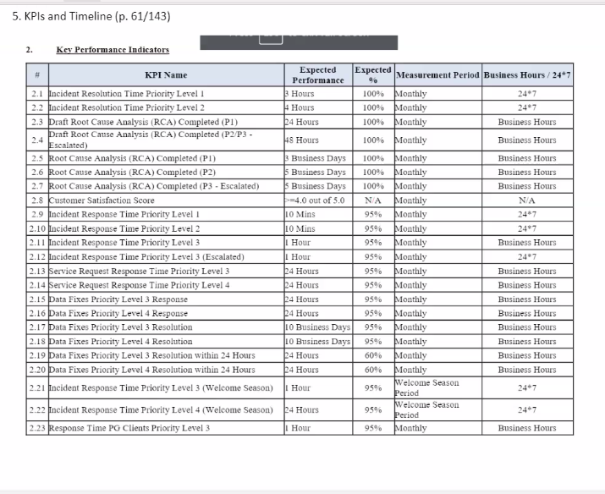

In areas where they are not doing better, we escalate that to a CSL.

**Dan: Have you had to do that? Escalations?**

Sri: No we haven't.